1Touch Project
2016 Annual Report

1Touch Project is a 501(c)(3) organization that provides ongoing self-development and rehabilitation courses through adapted self-defense training specifically for people who are visually impaired and members of society requiring physically adaptive activities.

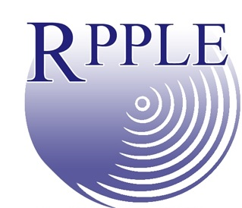
Programs
Presentations: 1Touch presentations are informative in nature and include oral presentations, poster sessions, and informational booths at conferences and meetings.

Workshops: 1Touch hands-on workshops can range from 1.5 hours to an entire day. These workshops create the environment of open discussion, question and answer time, and a chance to experience the effectiveness of the techniques firsthand.

Coaching Certification Course: 1Touch provides a 3-day intensive “train the trainers” course in order to reach the end users in their communities. As a program for distribution the coaching course enables others to teach the 1Touch syllabus in their constituency. A final exam must be successfully completed to earn a certification to maintain the standard of the program.

Mobility Impaired Coaching Certification Course: An optional 8-hour day of training can be added onto the Coaching Certification Course to learn the 1Touch Mobility Impaired Curriculum. This course is specifically designed for those people with prosthetics, walkers/support canes, and those who use wheelchairs.

Ongoing Classes: 1Touch coaches instruct classes in their local communities all across the United States. The courses can range in length from six weeks to ongoing courses.

Coach’s Conference: 1Touch provides an annual coach’s conference for coach’s to receive advanced training and provide networking opportunities.
Why 1Touch?

- In a pilot study conducted on the 1Touch Project by Dr. Tessa McCarthy, positive trends were found in psychosocial aspects in the areas of self-confidence, feeling safer on a daily basis, and feeling safer to travel independently.

- Positive trends were also found in areas of independent travel and travel after dark.

- Participants who were blind reported a reduction in the number of places in their community to which they would like to travel but didn’t because of fear.

- Individuals who were visually impaired but did not consider themselves blind reported an increase in the number of days they traveled independently each week.

- Participants also indicated an improvement in strength, endurance, and flexibility.

- On average, participants mastered 84.75% of the 76 steps involved in the key skills of the 1Touch program, with a range of mastery from 60.53% to 100.00%.

- When assessed six months after the initial training, the average level of skill mastery was 89.68% with a range of 53.95% to 100.00%.
Who we Serve!

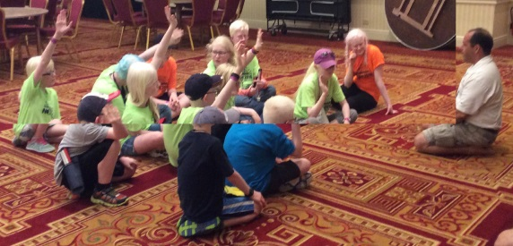

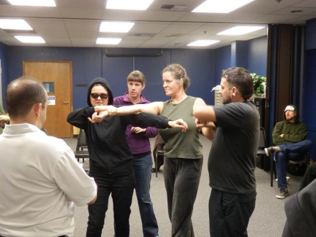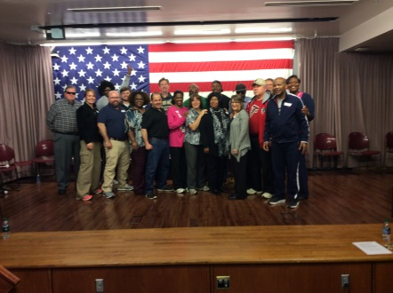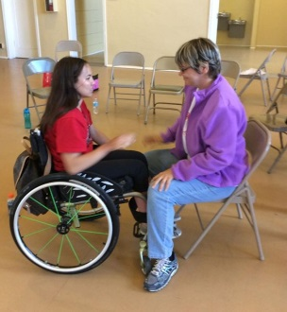

- People who are Visually Impaired/Blind
- People with Mobility Impairments
- People with Multiple Disabilities
- Professionals
- Veterans
- Children

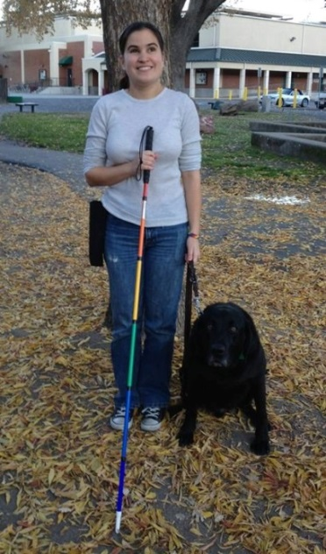
Stories From 1Touch Students
Dear 1Touch

I wanted to drop you a line to thank you for the amazing workshop on Saturday. I benefitted so much, not just from all we learned, but from your innovative and accessible approach, your sensitivity, and your obvious passion for and dedication to all you are doing.

I've attended several self-defense workshops which claimed to cater to the blind; none were even as half as engaging, well thought-out, or comfortable as 1Touch. Most left me feeling, if anything, more afraid and less empowered than I'd felt upon walking in. They typically focused primarily on making a scene, yelling for help, and hoping some Good Samaritan would eventually come along to assist. In contrast, 1Touch has clearly done their homework with incredible thoroughness and attention to detail, and I can't thank you enough. Two days later, I'm still amazed by this experience, and I wanted to take some time to write to both of you and explain why.

I was sexually assaulted—thankfully not violently—as a freshman in college, and though that was a rude and painful reminder that knowing self-defense was a necessity and ought to be a priority for me, everything was still too raw. The thought of facing another similar or worse incident was too much for me to process at that point, so I tried to avoid solo travel as much as possible and generally just crossed my fingers. Later, as I began to feel better and to widen my world again, I reconsidered self-defense but didn't know where to turn. I was especially reluctant to try any more blindness-specific training, after the unsatisfactory classes I'd experienced previously.1Touch, however, immediately came across as different, more thoughtfully developed and presented.

I don't mind telling you that I was extremely anxious going into Saturday: not because I doubted the two of you or the program—on the contrary, I knew I'd learn a lot and be in good hands—but because I was afraid of how I myself might feel and react. I've historically become both triggered and frustrated, even in respectful, instructive settings, when things like assault and our quote-unquote "vulnerability" as blind people are discussed in detail and at length. And in spite or perhaps because I've always been a touch-oriented person, a maximum of intense physical contact, even in a safe space and with people I trust, can become overwhelming. I very much wanted to do this training and felt ready for it, but I didn't want to disappoint either of you, or myself, by becoming upset or not being able to process what you were teaching.

I shouldn't have worried. You were both so aware, approachable, and sensitive (and Miranda, thanks for loaning me your puppy at the end there, when I really just needed some love and to calm down). I want to thank you both particularly for your kindness, attentiveness, compassion, and your sense of fun, which made the day, not just bearable, but educational and enjoyable and cathartic.

Thank you for insisting that we, as blind people, are not vulnerable; for caring enough to give me so much individual time, attention, and patience; for reminding me that, though it might be easier to stick my head in the sand, I have the capacity to do better and be stronger, tougher, and more courageous than that. Thank you, Stephen, for your gentleness, understanding, and playfulness; for listening to us enough to step inside blindness as a sighted ally, feel and acknowledge our fear, and help us face it; for explaining that bravery and fear balance; for making me feel better about my own experience when you said that, rather than looking back with regret on what we should have known and could have done better in a frightening situation, we should look forward, toward what we are capable of doing in the future if, God forbid, something happens again. Thank you, Miranda, for being so intuitive, descriptive, and creative in your help and descriptions; for not once becoming irritated with me when I tried too hard, was struggling to process, and inevitably became frazzled and flustered; for seeming to understand that, sometimes, I needed to be silly to keep from being upset. Thank you both for your insistence that I am capable; for your assurance that doing anything I can possibly do is better than not trying at all; for holding space for all of us; and for helping me relocate some of my bravery.

All this to say: thank you both, so very much, for all you do; my appreciation is honestly beyond words. Please please please keep up this tremendous work. I e-mailed everyone I know in the blindness field, both in California and outside of it, insisting that they call on you for any and all self-defense needs, and encouraging them to spread the word about 1Touch, both to students and prospective coaches. All blind people need to know about you and have the opportunity to work with you, and I promise to do all I can to make that happen. Your project is providing remarkable, singular tools for a population who has long since been in desperate need of guidance, especially since, as we discussed, other agencies are often neither willing to work with us nor to take the time to learn to do so adequately.

Take care, be well, and keep on fighting the good fight, always.

Yours sincerely,
Caitlin Hernandez
__________________________

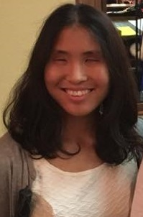
“I was always more or less confident in my travel skills as a blind student however, I always wondered what would happen if I was placed in a situation where I actually needed to defend myself. As I graduated to a university setting, that fear became all the more prevalent. It did not ever stop me from going out and about, but it was always in the back of my mind. Before I took my first 1Touch™ workshop, I had always believed self-defense was impossible for the blind to achieve, as it relied heavily upon visual cues. Due to this misconception, I believed that if I ever was to be attacked, I would be at a severe disadvantage.

1Touch™, and the principles it demonstrates, showed me that was, in fact, not the case. Through the techniques I was shown, and which I eventually strove to learn, I found that I could indeed defend myself as well as any of my sighted peers. Then, one day I was placed in a situation where I had to employ those techniques. An assailant cornered me in an empty room and blocked my access to the door. When he grasped me, my training kicked in. To this day, I believe that made the difference as to whether I let things get worse or took command of the situation. I did the latter, and since I did not wish to inflict any permanent damage, I used a finger lock to break his grip and force him from the room. It was only after the fact that I realized 1Touch™ might very well have saved my life.

1Touch™ has not only given me increased self-confidence, but also the means with which I can handle a potentially dangerous situation with minimal risk to myself. I sincerely wish for other students to have the same experiences, and though I am not yet a Coach, I hope to continue setting up these workshops so that others can be given the same opportunities I have received through engaging in training”. - Su Park
__________________________

“I recently had the privilege and joy of participating in a 1Touch coaching certification course. Twelve Lighthouse staff and community members took part in a three day training which just blew my mind. We covered so much material and had so much fun doing it. Although we left completely exhausted each night, we left knowing so much information, from how to distance oneself from an unwanted touch to how to file a witness report. At the conclusion of the three day seminar, we all walked away more confident, alert and ready to give back to the blindness community in the most meaningful and best way possible ... as certified 1Touch coaches. If you are considering taking a workshop to feel more safe and confident out in the world, or if you are considering becoming a coach, don't hesitate! Just do it. This is one of the best things you can possibly do for yourself and for your community”. Lisamaria Martinez – San Francisco Lighthouse
______________________

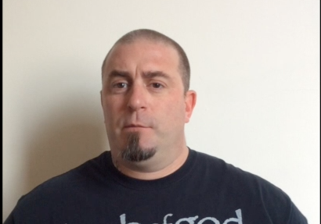
My name is Jake Pricer and I am 39 years old. I became low vision 1 ½ years ago when I was diagnosed with a rare eye condition. As my vision loss progressed I was looking for everything and anything to give me more confidence to continue to live my life. 1Touch has brought me what I was looking for. It has brought me confidence, independence and the ability to feel more comfortable in my own skin; I highly suggest everyone who is blind or visually impaired take a 1Touch class. 1Touch is great fun and could become a career choice for me in the future.

Coaching Certification Courses!

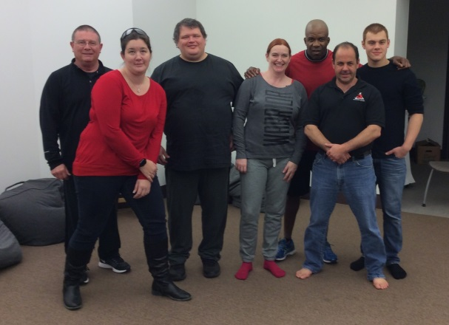
St. Louis, MO - Delta Gamma Center for Children with Visual Impairments

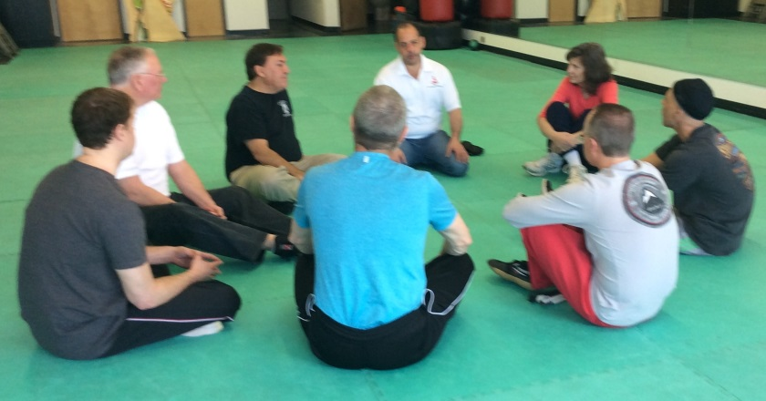
Fort Collins, CO – International Black Belt Academy

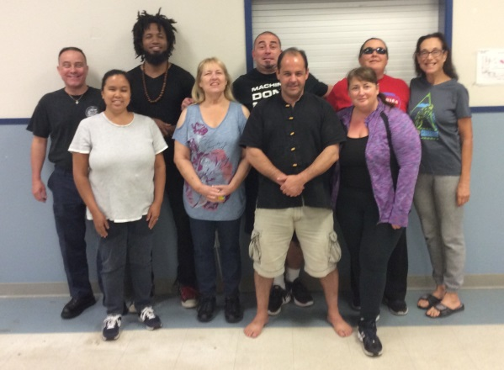
Stockton, CA - Community Center for the Blind

Coaching Certification Courses
(Continued)

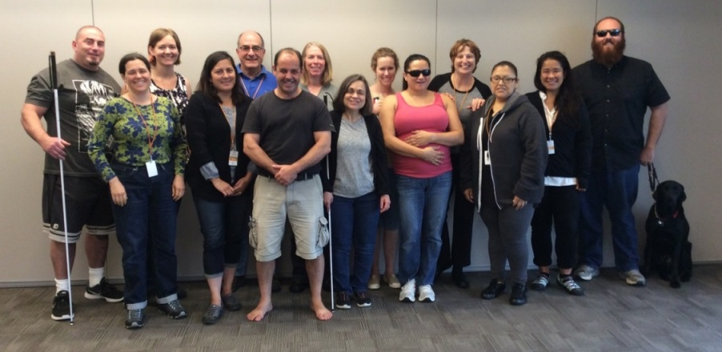

San Francisco, CA
San Francisco Lighthouse for the Blind

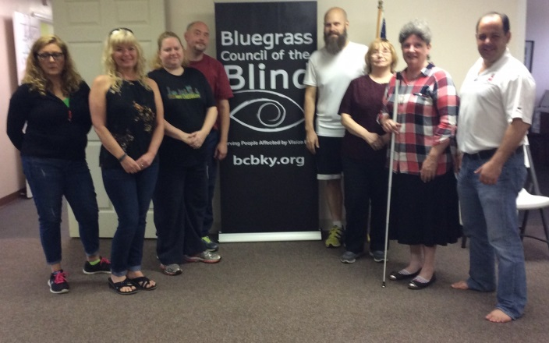
Lexington, KY - Bluegrass Council of the Blind

A Special Thank You

Thanks to the generosity of the Delta Gamma Foundation we were able to hold a funded Coaching Certification Course in Lexington, KY at the Bluegrass Council of the Blind!

A big thank you to the Ohio Lions Foundation for funding a 2 day introductory workshop for 50 clients of the Cleveland Sight Center!

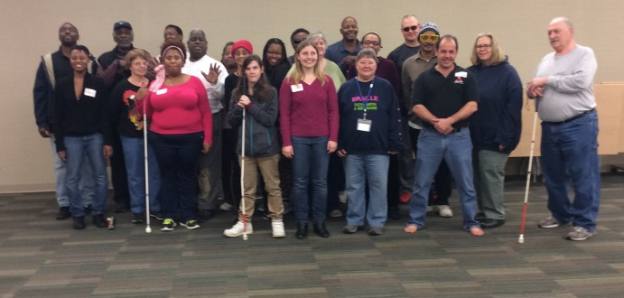

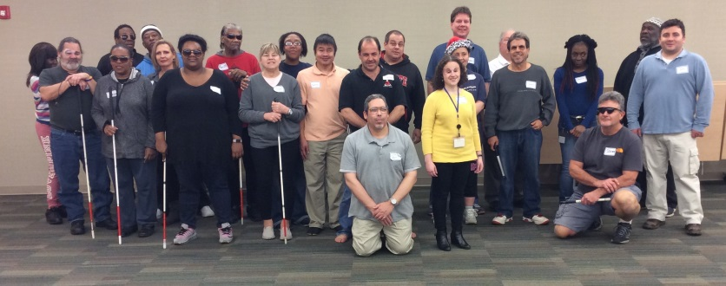

1Touch Workshops and Classes

No Barriers Summit
NFB National Convention
ACB National Convention
NOAH National Conference
AER International Conference
VA TEE Tournament
National Industries for the Blind Conference
Vista Center for the Blind
Orientation Center for the Blind
City of Reno
Earl Baum Center for the Blind
Cleveland Sight Center
St. Marcos, Austin, TX
Perkins School for the Blind
Camp Abilities (various locations)
NFB Chapters (various locations)
ACB Chapters (various locations)
Philadelphia Associated Services for the Blind
Fort Collins Therapeutic Recreational Center
Second Sense
Georgia Academy for the blind
Colorado State Division of Rehabilitation
Blind.Inc
Louisiana Centre for the Blind
Janesville School for the Blind
Lighthouse Center for Vision Loss
JKL Bahweting School
NC Rehab Center for the Blind
INL North west lighthouse for the blind
Thank You to Our Donors!

VA Adapted Sports Grant
Healthy Vision Association
Delta Gamma Foundation
Ohio Lions Foundation
City of Reno
St. Louis Lighthouse for the Blind
Orscheln Industries Foundation Inc.
Air Choice One
Casey’s General Store
Oliver Hu
Bill Cozzini
Dr. Steven Brodsky
Burlington Kiwanis Club
Leverett Flint
Josh and Regina Silvers
Mike Sedmak
Bill Brown
Cynthia Coolidge

Donate or Become a
Volunteer Today!
info@1touchproject.com
www.1touchproject.com
www.facebook.com/1touchproject

